Jennifer Gore
Professor Emerson
English 110I
April 11, 2018
Narrative Relating to our Identity
Every day we go about our lives, and sometimes unintentionally create memories. These memories are the fuel that keeps us going, and the place where we can look back on and grow as individuals. For me, a memorable experience can not only be a happy one, but a time that consists of sorrow, pain, or fear. It is these memories that keep us in check for our futures, whether making us grateful for what we have, or teaching us valuable life lessons. Without the knowledge of our good and bad days we are nothing. Although this is true, what else can we do with these memories of ours? Why not share our darkest days, our happiest days, the days we feared and the days we laughed? This is where narrative comes in to play. Narrative is our truths. The stories we hear from our grandparents, our parents, our friends, books and the media-- they are all narratives. When I hear stories from others, and they are brave enough to share their experiences, not only does it provoke insight, but the narratives they tell, inspire. I believe that narrative has an impact on all of our identities, and can promote the development of self by learning and changing the outlook of our lives just by hearing others’ stories, and at the same time, can also shape one's’ identity by sharing your own stories.
For centuries, the human race has passed down knowledge from generation to generation. Most of this knowledge is through narrative. A great example of this, is how the Native Americans used stories to pass down there legends and myths, or there beliefs about the Gods, heroes and deities.
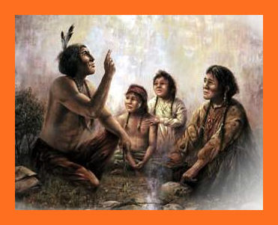
“Native American oral storytelling traditions allowed tribes to transmit their mythological, spiritual and historical understandings of themselves and the worlds they inhabited to their children and
their children’s children. This all but guaranteed that members of each individual Indian nation would never forget their roots or lose sight of important knowledge that would allow them to continue to exist in harmony and cooperation with the natural world.” (Storytelling Traditions of Native Americans)
Native Literature Oral History

The Native Americans initially used narrative and storytelling because it was essential for their knowledge to survive the years, even after written language arose. From doing this, their children and so on can learn from their mistakes AND triumphs, to ensure a better future for themselves. Hundreds of years later, who is to say that this method isn’t still applicable for us today? Julie Beck, in her article, “Life’s Stories” which is about the importance of narrative in our lives, playing a fundamental role in our perspective on life, says,
“A life story doesn’t just say what happened, it says why it was important, what it means for who the person is, for who they’ll become, and for what happens next.”

Beck is conveying how there are multiple facets to narratives, and the things we can take away from them as we listen from an outside perspective. We learn in our schools, math, science and English, but it is from the people around us, who we learn the most from.
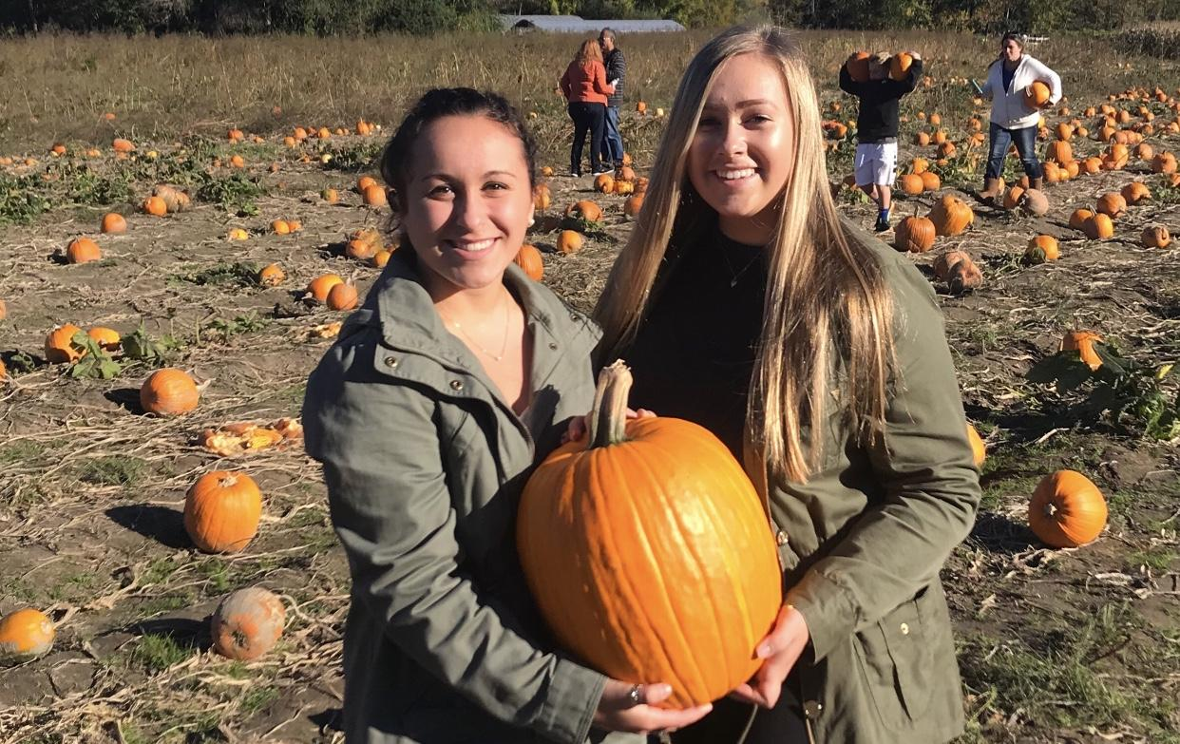
I believe that narrative also has the power to change the outlook of our lives, and can inspire change within ourselves and others. Yes, we learn from stories--those from ourselves and others-- but what we do with that information is what truly matters. When
I interviewed my roommate Alessandra, she discussed with me her life with microtia. Microtia is a deformity of the ear and as a result it makes her deaf in that ear. After she shared with me her narrative in detail, I asked her how does it feel to know your story will be told. She she said:
“It makes people feel they are not alone”
This quote is very applicable with all types of narratives. Our society puts people in a box, where conformity is expected and anything that diverges from that is not welcomed, but with the help of narrative, it allows others to relate and not feel outcasted or isolated.
I also think that telling your own story-- your own narrative at that--is a way of self-medication, and self-expression, and can shape your identity. Galen Strawson, a British analytic philosopher and literary critic, says in his article “I am not a Story”,
“I don’t think an ‘autobiographical narrative’ plays any significant role in how I experience the world”.
I deeply resent that.
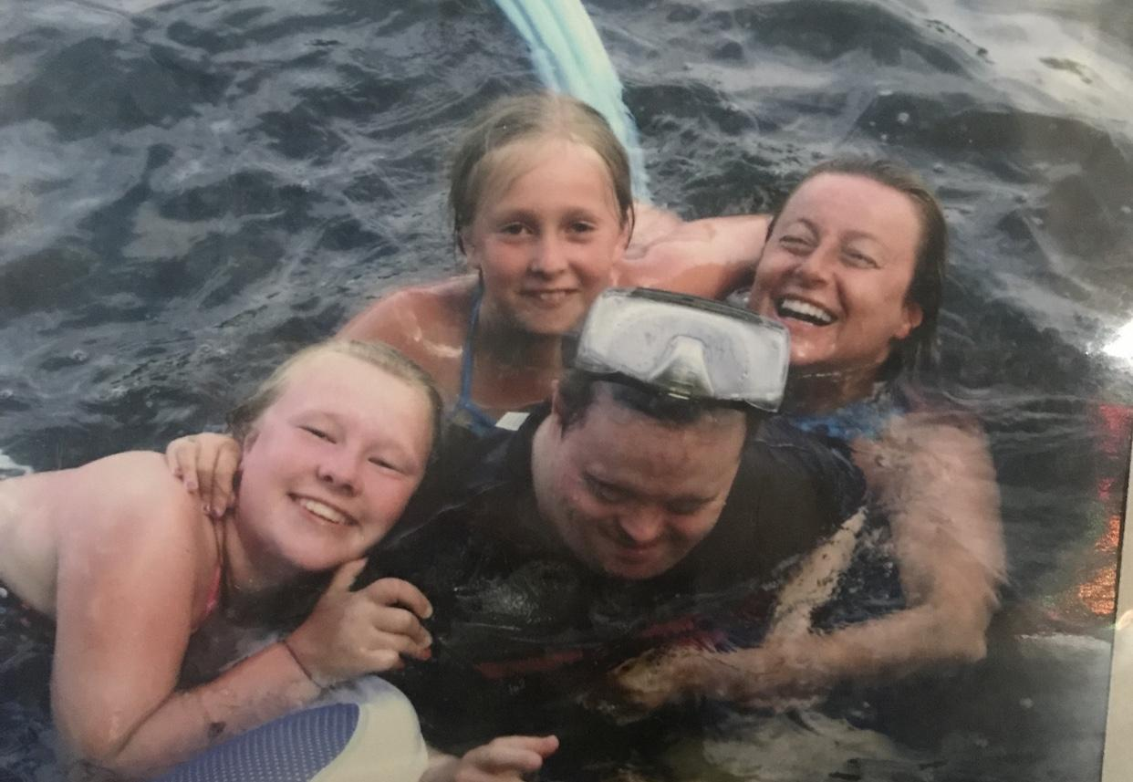
When sharing your narrative, whether it be writing it down or saying it out-loud, your giving apart of yourself to the world. With your story now out in the open, it can give you a sense of relief, discouragement, curiosity, amazement, etc. about you perceive said world. One narrative I like to tell my friends is my experiences with my Uncle who has Down Syndrome. The stories I tell are the funny moments I share with him and how
some of my favorite memories are from being with him. I feel as though whenever I tell my narrative, my story, I look at the world around me much differently than before. I think of how grateful I am to have someone like that in my life, how the world can be a cruel place to people who are different, and it reminds me how I should always treat everyone equally. Beck states:
“This narrative becomes a form of identity, in which the things someone chooses to include in the story, and the way she tells it, can both reflect and shape who she is”
So, not only can narrative affect how we experience the world but the act of sharing our narrative can reflect who we are as a person. Have you ever heard someone tell a story? From there tone, there demeanor, how slow or quick they tell their story, and more can tap into their personality and show their identity.
Narrative has an impact on all of our identities, and can promote the development of self by learning and changing the outlook of our lives. At the same time, narrative can also shape one's’ identity by sharing your own stories. People tell stories for many reasons, but behind those reasons lies a person's’ true self, and if we listen close enough we can uncover more than we could imagine. Narrative has power.

Works Cited
Beck, Julie. The Story of Your Life. The Atlantic, Atlantic Media Company, 10 Aug.
2015,
www.theatlantic.com/health/archive/2015/08/life-stories-narrative-psychology-redemption-mental-health/400796/. Accessed 10, April 2019.
Native Literature Oral History. 2013. Native Literature - What Is Native American
Literature?,
2013, nativeliterature.org/home. Accessed 10 April, 2019.
Strawson, Galen. I am not a Story. Aeon, Aeon,
aeon.co/essays/lets-ditch-the-dangerous-idea-that-life-is-a-story.10 Apr. 2019.

Multimodal Statement
The multimodal choices include the underlining, and changing of the color of important sentences or phrases within my essay. I also centered, enlarged and highlighted important quotes yellow from Julie Beck’s text. I did this because I agree with what she had to say. On the other hand, I decreased the size and highlighted the text grey for Galen Strawson’s quotes. I did this because I disagree with what he said. When I did this, it allowed for my readers to notice what I wanted them to notice, and disregard/not pay too much attention to the things I felt were unimportant. This way, my readers know exactly what I’m trying to argue. I also added 3 pictures to my essay. These pictures clearly resemble what I was describing in my text, and gives the readers a visual to what I was talking about. For instance, for my paragraph about Native Americans, I included a picture of an elder telling an oral story. When I was talking about my interview with Alessandra, my roommate, I included a picture of me and her so the audience can feel a deeper connection. My last picture showed me, my sister, my aunt and my uncle. It resembled the types of narratives I would tell or often think about, which all related to the text. Lastly, I included a hyperlink of the video of my interview. Overall, I feel that all the modes I decided to include in my essay enhanced my argument and drew connections.

